- Open remix ide , in the remix ai assistant type the below prompt and create a calculator contract
Prompt
Create a simplecalculator contract , write functions to add,subtract,multiply and divide
Click on approve
It will create a calculator.sol contract under contracts like below

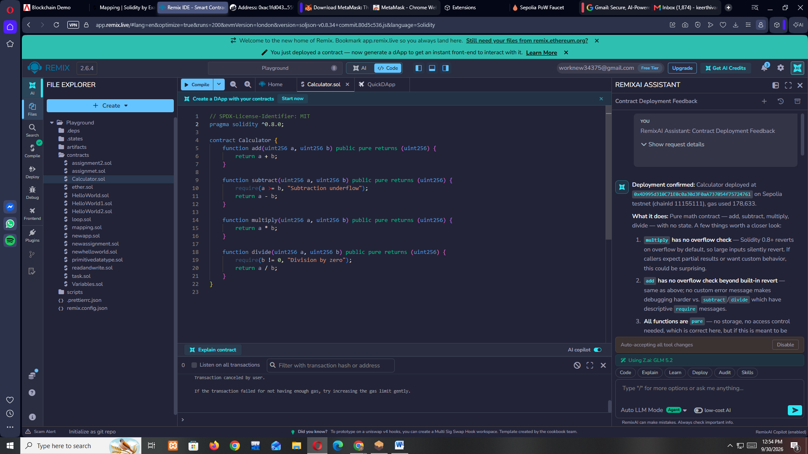

2.click on compile in default environment which is remix vm and Osaka and deploy

- change it remix vm and London
Compile again
4.now open ganache , create a new workspace
Enter a name and click on start
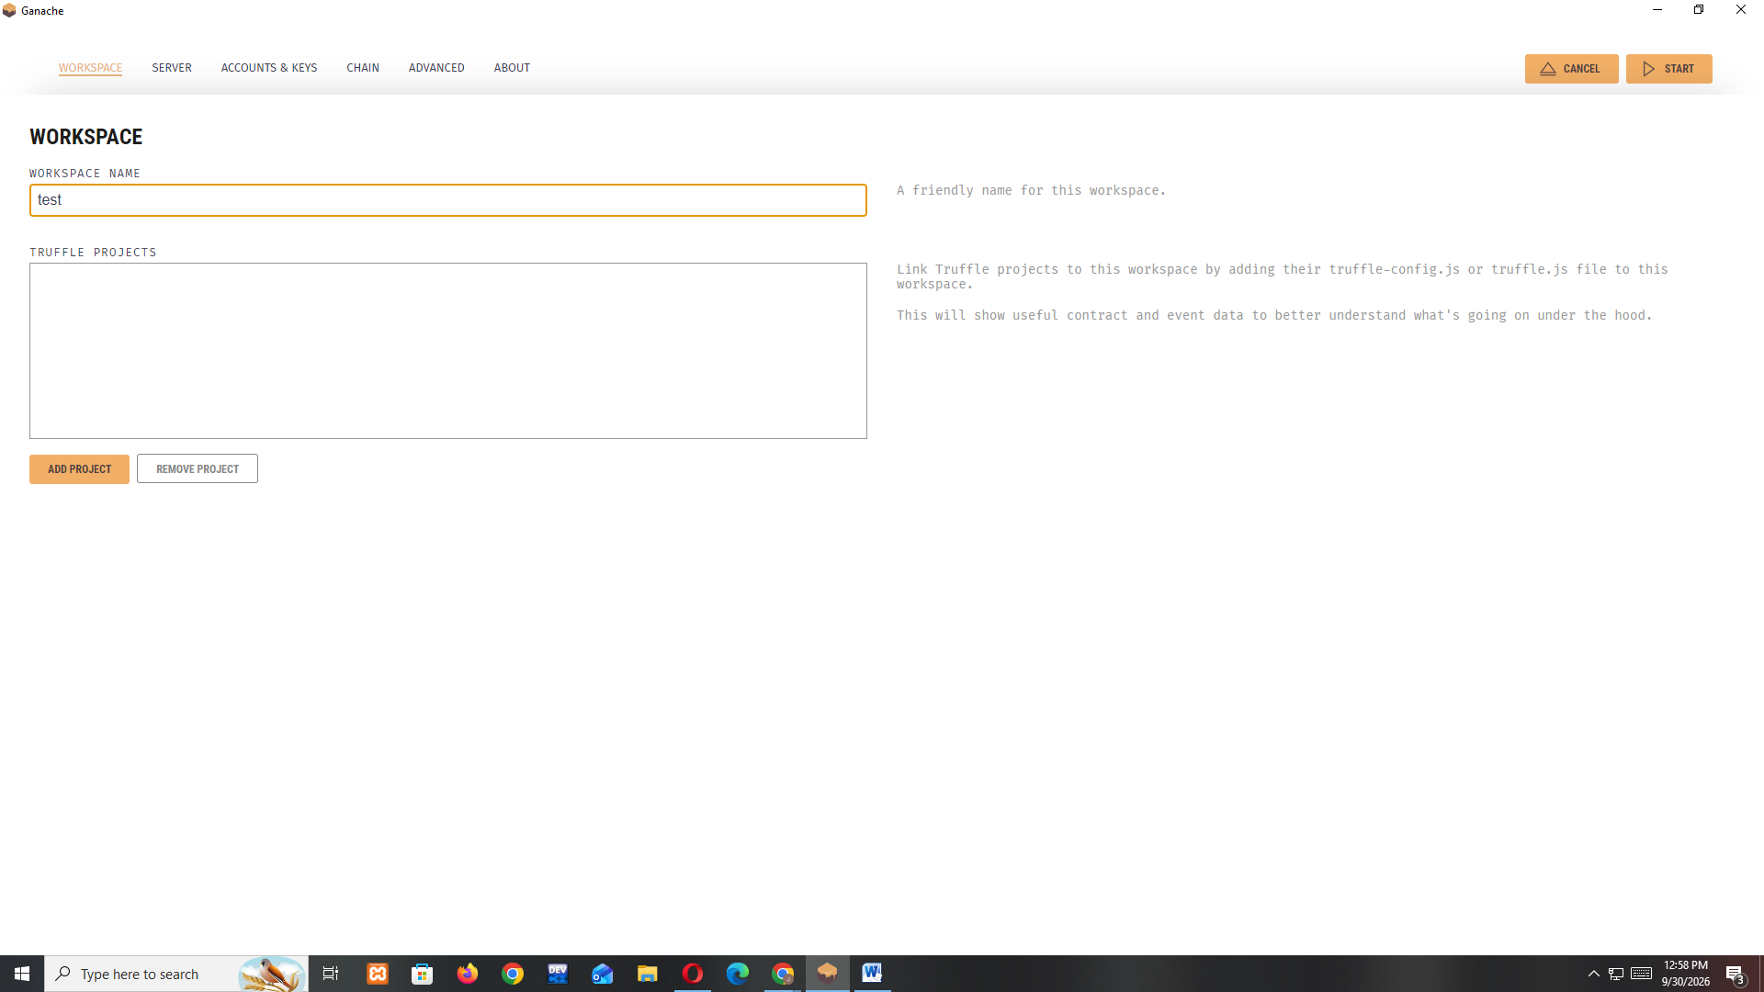

5. In your remix ide now change the environment to dev and ganache provider,it will show a pop up change the rpc endpoint from http://127.0.0.1:8545 to http://127.0.0.1:7545 compile again and deploy
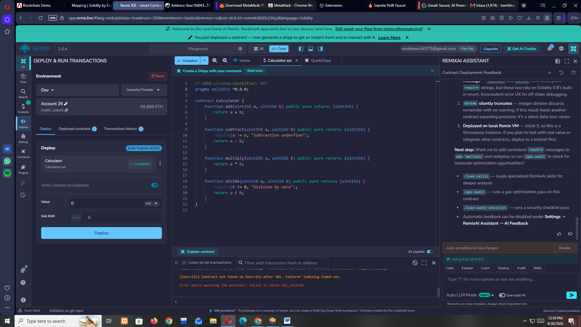

6. if successful you will see the transaction reflect in your ganache under transactions like below
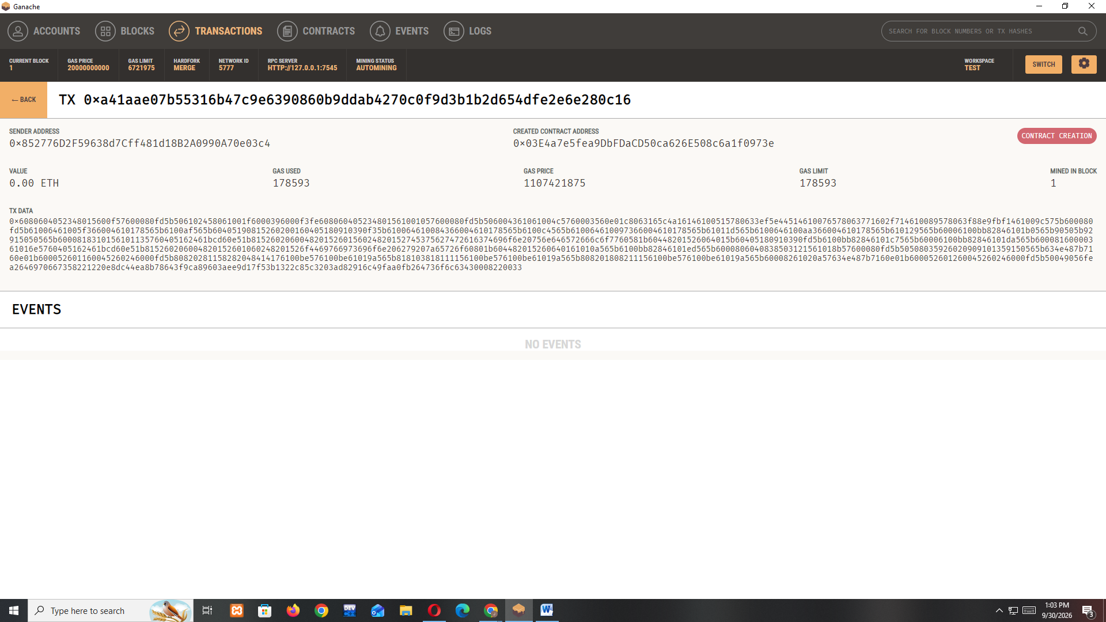

7. if this step fails . copy paste the error in remix ai and approve the changes to fix it , then compile and deploy again , this is the output I got when I copy pasted the error in remix ai , once I approved it I was able to compile and deploy successfully

The issue is an EVM version mismatch — compiler 0.8.34 targets a newer EVM than Ganache supports. Let me set the EVM version to london.

I'll first check the current compiler config to confirm the exact version string format, then set the new config accordingly.

Now I'll set the compiler config to use EVM version "london" while keeping the current version, optimization off, and runs at 200.

The compiler config is now set with:

Version: 0.8.34+commit.80d5c536.Emscripten.clang (kept as-is)
EVM version: london
Optimization: off
Runs: 200
Now I'll recompile the contract at /contracts/Calculator.sol.

The compilation of contracts/Calculator.sol completed successfully with the updated compiler config. Here's a summary:

Compiler Config Used
Setting Value
Version 0.8.34+commit.80d5c536.Emscripten.clang
EVM Version london
Optimization Off
Runs 200
Compilation Result
Status: ✅ Success (no errors, no warnings)
Contract: Calculator at contracts/Calculator.sol
ABI Functions (all pure):
add(uint256 a, uint256 b) → uint256
subtract(uint256 a, uint256 b) → uint256
multiply(uint256 a, uint256 b) → uint256
divide(uint256 a, uint256 b) → uint256
Gas Estimates:
Creation: codeDepositCost = 251,800, executionCost = 294, totalCost = 252,094
External calls: all infinite (typical for pure arithmetic functions with unbounded input)
Compilation succeeded with london EVM version. The error was likely caused by PUSH0 opcodes (default in newer Solidity) that Ganache doesn't support. The recompiled bytecode should now be compatible. Try deploying the Calculator contract again from the Deploy & Run panel.

You
RemixAI Assistant: Contract Deployment Feedback
AI
✅ Calculator deployed to 0x6260854847230B46c91F1452cCFdA729cD36Fc63 on chain 1337 (Ganache), using 323,238 gas.

A simple pure-math contract with four uint256 arithmetic functions. Things worth noting:

No overflow protection needed — Solidity 0.8+ has built-in checked arithmetic, so add/multiply will revert on overflow automatically. Good, but worth being aware of if you ever downgrade the compiler.
divide truncates — integer division discards the remainder (e.g., divide(7,2) returns 3). If you need precision, consider returning quotient + remainder or using fixed-point math.
All functions are external pure — no storage, no access control, no edge cases beyond the two require checks. This is about as safe as a contract gets.
Want me to run /gas-audit to see if there's any gas to squeeze out, or would you like to add new functions (e.g., power, modulo) to the contract?

/load-skills — load specialized skills for deeper analysis
/gas-audit — run a gas optimization pass
/load-audit-checklist — run a security checklist pass
Automatic feedback can be disabled under Settings → RemixAI Assistant → AI Feedback

